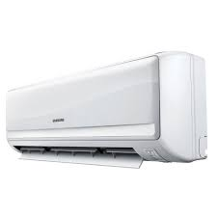

AS12UGBN

Capacity/Size 1Ton

Cooling Capacity 12000 BTU

AC Type Split Type

Technology Conventional

Rs.89,000